The other 98%

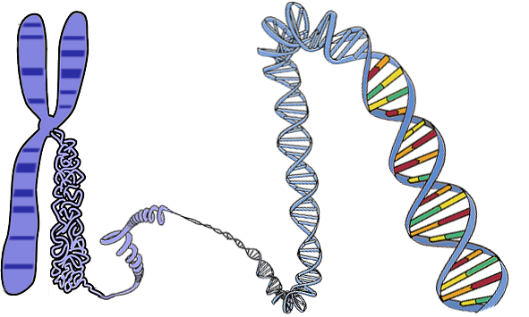
genes
DNA

Genes are regions of DNA in your genome.
Scientists estimate that genes are only about 2% of your genome.

The table contains statements about the other 98% of your genome.
Some of the statements are right and some are wrong.
Tick one box for each statement.

Statements |  | I am sure this is right | I think this is right | I think this is wrong | I am sure this is wrong
1 | Cells use the information coded in the other 98% as instructions to make proteins.
2 | It’s just junk.
3 | Cells use the information coded in the other 98% to control when genes are used.
4 | The information coded in the other 98% can affect our characteristics.

Biology> Big idea BHL: Heredity and life cycles > Topic BHL1: Inheritance and the genome > Key concept BHL1.2: The structure and function of the genome
Diagnostic question
The other 98%

Overview
Learning focus: | The structure and function of organisms depends on proteins made by cells using instructions stored in the DNA of the genome.
Observable learning outcome: | Apply the idea that cells use the information stored in other regions of the genome to control when genes are used.
Question type: | Confidence grid
Key words: | genome

B | BRIDGING  This diagnostic question probes understanding of ideas that are usually taught at age 14-16, to build a bridge to later stages of learning.

What does the research say?
Defined simply, the genome is the entire DNA of an organism. Recent estimates suggest that genes (“coding” regions of DNA whose sequences encode the order in which amino acids are joined together to make proteins) make up less than 2% of the DNA in the genome (Pennisi, 2007); up to 80% of the remaining “non-coding” DNA – historically mischaracterised as “junk” – is important in controlling gene expression (how and when genes are used to make proteins). Most heritable traits are affected by multiple regions of coding and non-coding DNA.
Science education researchers have acknowledged that we live in a genomic era. The genomes of humans and many other organisms have been sequenced, and the study of the functions and importance of genes has broadened to whole genomes. Teaching and learning about inheritance and genetics at school must aim to prepare students to live and work in the genomic era (Stern and Kampourakis, 2017).
Up to the age of 14, a useful approach may be to embed ‘pro-genomics’ and ‘pre-genomics’ practices – for example, use of language and concepts that dispose students to thinking about whole genomes rather than just genes, and that represent the first steps on a learning progression that will enable fuller understanding of genomics to be built later (Airey, Moore and Bennett, 2018).
Ways to use this question
Students should complete the confidence grid individually. This could be a pencil and paper exercise, or you could use the presentation with an electronic voting system or mini white boards.
Differentiation
You may choose to read the statements to the class, so that everyone can focus on the science. In some situations it may be more appropriate for a teaching assistant to read for one or two students.

Expected answers
- Cells use the information coded in the other 98% as instructions to make proteins – wrong (the information coded in genes – the 2% – is used as instructions to make proteins)
- It’s just junk – wrong (up to 80% of it is important in controlling gene expression – i.e. how and when genes are used to make proteins)
- Cells use the information coded in the other 98% to control when genes are used – right
- The information coded in the other 98% can affect our characteristics – right
How to respond - what next?
If there is a range of answers, you may choose to respond through structured class discussion. Ask one student to explain why they gave the answer they did; ask another student to explain why they agree with them; ask another to explain why they disagree, and so on. This sort of discussion gives students the opportunity to explore their thinking and for you to really understand their learning needs. Responses often work best when the activities involve paired or small group discussions, which encourage social construction of new ideas through dialogue.
Researchers have used constructivist approaches that enable students to build their own explanations of the structure and function of DNA and the genome, which may help to develop students’ understanding and overcome misconceptions, including the use of group discussions (e.g. Lewis and Kattmann, 2004). If students have misunderstandings about how genes (coding regions) and non-coding regions of the genome are used by cells, it may be helpful to think in terms of metaphors related to everyday concepts. The following BEST ‘response activity’ challenges students, in groups, to describe how different regions of the genome work together, and could be used in response to this diagnostic question:
- Response activity: Genome journalist
Acknowledgments
Developed by Alistair Moore (UYSEG).
Images: adapted by UYSEG from pixabay.com/OpenClipart-Vectors (156404)
References
Airey, J., Moore, A. and Bennett, J. (2018). Viewed as a whole: syntheses of research evidence and teaching support resources related to genomics education in schools. A report to the Wellcome Genome Campus Public Engagement Team: University of York, UK.
Lewis, J. and Kattmann, U. (2004). Traits, genes, particles and information: re-visiting students' understandings of genetics. International Journal of Science Education, 26(2), 195-206.
Pennisi, E. (2007). DNA study forces rethink of what it means to be a gene. Science, 316(5831), 1556-1557.
Stern, F. and Kampourakis, K. (2017). Teaching for genetics literacy in the post-genomic era. Studies in Science Education, 53(2), 193-225.

